Ideation Phase
Brainstorm & Idea Prioritization Template

Date | 31 January 2025
Team ID
Project Name | Ecommerce
Maximum Marks | 4 Marks

Brainstorm & Idea Prioritization Template:
Brainstorming provides a free and open environment that encourages everyone within a team to participate in the creative thinking process that leads to problem solving. Prioritizing volume over value, out-of-the-box ideas are welcome and built upon, and all participants are encouraged to collaborate, helping each other develop a rich amount of creative solutions.
Use this template in your own brainstorming sessions so your team can unleash their imagination and start shaping concepts even if you're not sitting in the same room.

Step-1: Team Gathering, Collaboration and Select the Problem Statement

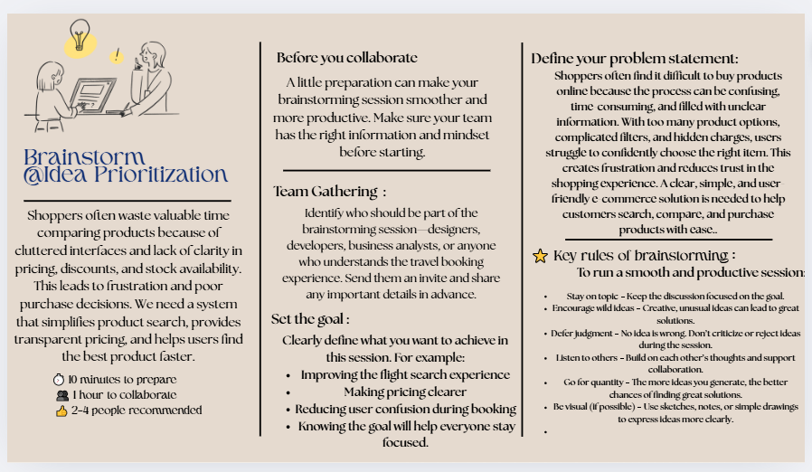

Step-2: Brainstorm, Idea Listing and Grouping:
BRAINSTORM

1. Simple
- Customers struggle to find and buy products easily due to cluttered interfaces, confusing filters, and hidden charges.
- Online shopping takes too long because users can’t quickly compare products or trust the pricing.

2. Medium-Length Variations
- Shoppers often feel overwhelmed by too many choices, unclear prices, and complicated filters, making it hard to find the right product.
- Many e-commerce platforms offer inconsistent prices, slow searches, and confusing layouts, which reduce user trust and confidence.
- Customers waste time trying to understand product differences and hidden fees, leading to frustration during checkout.

3. Detailed Versions
- Users find it challenging to navigate e-commerce websites because the product search and comparison experience is cluttered, slow, and unclear. Hidden charges, poor filtering systems, and inconsistent pricing make it difficult for them to make confident purchase decisions.
- Most shoppers face an overwhelming amount of information when trying to buy products online. Complicated filters, unclear discount rules, and unreliable reviews cause frustration and prevent smooth purchasing.

4. User Pain-Focused
- Shoppers are frustrated by unclear prices, fake reviews, overwhelming product options, and slow search results.
- Customers worry about overspending because discounts and fees are not properly explained.
- Users lack trust due to inconsistent product information and hidden costs.

5. Business-Focused (Why it matters)
- Complex shopping workflows cause users to abandon carts, leading to lost revenue.
- Lack of clarity in product pricing reduces customer trust and repeat purchases.
- Poor search and filtering leads to low product discoverability and lower conversion rates.

6. Creative / Human-Centered
- Customers come to shop, not fight through confusing menus, slow filters, and hidden fees. They want simplicity, honesty, and speed.
- Shoppers don’t want to decode pricing tricks or dig through endless filters—they just want a clear path to the right product.

7. Solution-Linked
- E-commerce needs a clean, transparent, and intuitive shopping experience that helps users find the right product faster, compare easily, and buy without confusion.
- A simplified product discovery system can eliminate confusion and restore user confidence by offering transparent pricing and easy navigation.

